

Database System

Iqra Batool

Mansoob-e-Zahra

Takreem Atif

CIS(23 – 27)

Project Report : Food Delivery App

Submitted to : Dr Irfan Hameed
Submission Date : December 9,2025

Table of Contents
On-Demand Food Delivery Service Database 4
Introduction: 4
Project Description : 5
Key Stakeholders 5
Core Business Workflow 5
Business Rules 5
Enterprise Data Model: 6
Entities 6
Relationships 6
1. Order — Payment Relationship 6
2. Rider — Order Relationship 7
3. Restaurant — Order Relationship 7
4. Restaurant — MenuItem Relationship 7
5. Order — OrderItem Relationship 8
6. MenuItem — OrderItem Relationship 8
Entity Relationship Model: 10
Entities & Attributes 10
Relationships & Cardinality 12
1) Customer and Order 12
2) Restaurant and Order 12
3) Rider and Order 13
4) Order and Payment 13
5) Restaurant and MenuItem (Product) 14
6) Order and OrderItem 14
7) MenuItem and OrderItem 15
Relational Model: 17
Entities Tables 17
Relational Tables 19
Relational Schema 20
Integrity Constraints 20
Final Relational Schema 22
Normalization: 23
1. First Normal Form (1NF) 23
2. Second Normal Form (2NF) 24
3. Third Normal Form (3NF) 25
Normalization Scenario 27
Normalizing to Second Normal Form (2NF) 27
Normalizing to Third Normal Form (3NF) 28
SQL Code 30
Database Setup 30
TABLES 30
Data Insertion 33
Users, Roles, and Access Control (DCL) 41
TRIGGERS 45
Transactions 54
ROLES 58

On-Demand Food Delivery Service Database

Introduction:

The On-Demand Food Delivery Service Database project focuses on designing and implementing a structured and reliable Relational Database Management System (RDBMS) to support the complete operational workflow of an online food-delivery platform. The goal is to build a database that accurately manages customers, restaurants, menu offerings, orders, riders, and payment transactions, while ensuring data integrity, consistency, and secure access. Using SQL Server, the project emphasizes strong schema design, proper normalization, enforcement of referential integrity, and implementation of transactional rules that reflect real-world business operations.
The database serves as the central backbone that enables the platform to process orders efficiently—from menu browsing and ordering to dispatch, delivery, and payment settlement.

Project Description :

Key Stakeholders
The system is built around coordinating these five parties:
- Customer: Places orders, pays, and submits reviews.
- Restaurant (Vendor): Accepts, prepares, and confirms order fulfillment.
- Rider (Delivery Agent): Picks up orders and completes the delivery.
- Admin / Platform: Manages the entire operation, user onboarding, finances, and customer support.
- Payment Gateway: Handles all financial transactions (Card, Online, or COD settlement).

Core Business Workflow
The process follows a logical sequence centered on the Order entity:
- Order Placement: The Customer selects a menu, chooses a payment method (stored in the Payment table), and places the order.
- Preparation: The system sends the order to the Restaurant, which accepts it and updates the status to "Preparing."
- Dispatch: As the food nears completion, the platform locates an available Rider and assigns the delivery job.
- Transit: The Rider picks up the order ("Picked Up") and delivers it to the customer ("Delivered").
- Settlement: The Payment is confirmed (via Gateway or COD collection), and the platform distributes funds to the relevant parties.
- Feedback: The Customer finalizes the loop by reviewing the service.

Business Rules
- An Order must contain at least one Menu Item.
- A Customer can place many Orders.
- A Restaurant must offer one or many Menu Items.
- A Menu Item must be offered by one and only one Restaurant.
- An Order must be delivered by exactly one Rider (once assigned).
- An Order is linked to exactly one Payment.
- A Payment is linked to exactly one Order.
- Online payments are preferred, and a bill can be generated even if the order is not placed at the restaurant.
- An Order must be placed by one and only one Customer.
- An Order must be fulfilled by one and only one Restaurant.
- A Rider can deliver many Orders.
- An Order must contain one or many Order Items (line items).

Enterprise Data Model:

Entities
- Customer
- Restaurant
- Rider
- Order
- MenuItem
- Payment

Relationships

Order — Payment Relationship
Payments are created for orders to record how each transaction is financially settled.

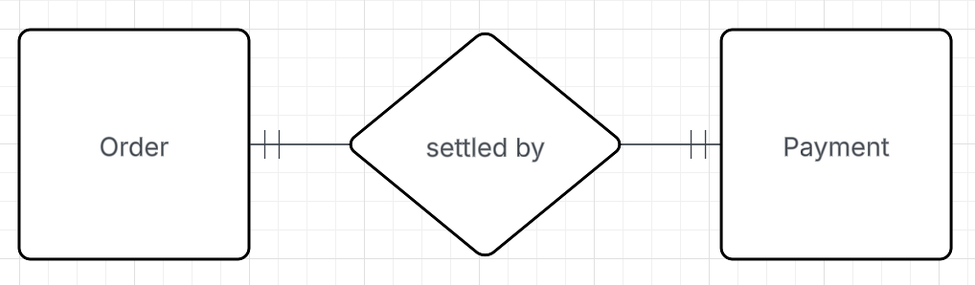
- Customer — Order Relationship
Customers interact with the system by placing food orders.

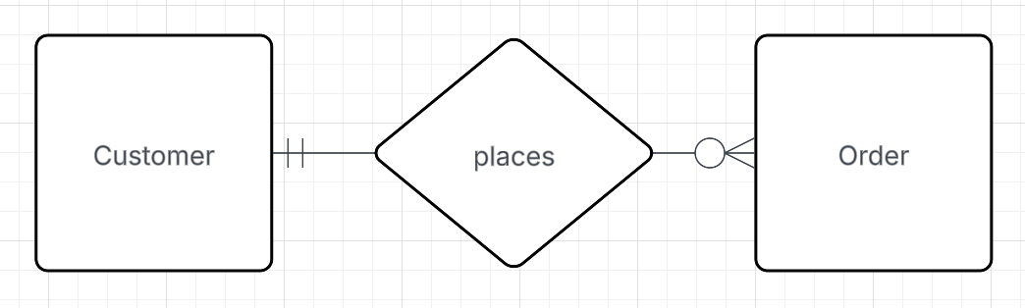

Rider — Order Relationship
Riders are responsible for transporting prepared orders from restaurants to customers.

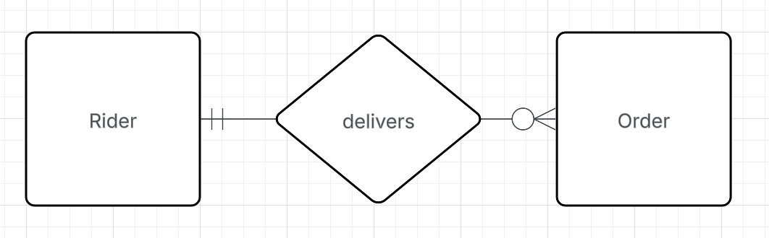

Restaurant — Order Relationship
Restaurants receive and fulfill orders submitted by customers.

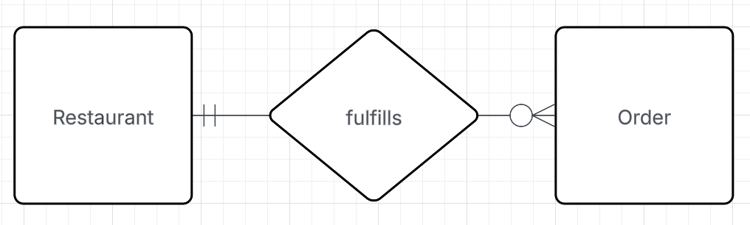

Restaurant — MenuItem Relationship
Restaurants offer a variety of menu items to customers.

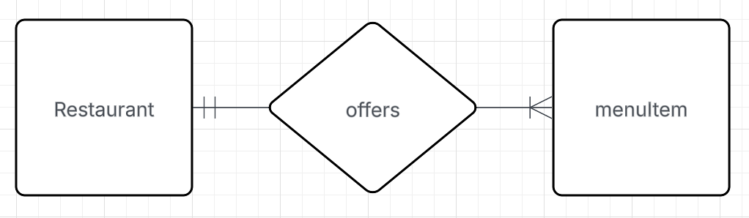

Order — OrderItem Relationship
Orders consist of multiple items selected by customers.

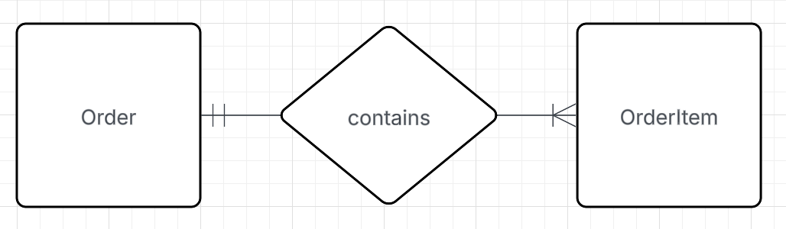

MenuItem — OrderItem Relationship
Each order item corresponds to a specific menu item offered by a restaurant.

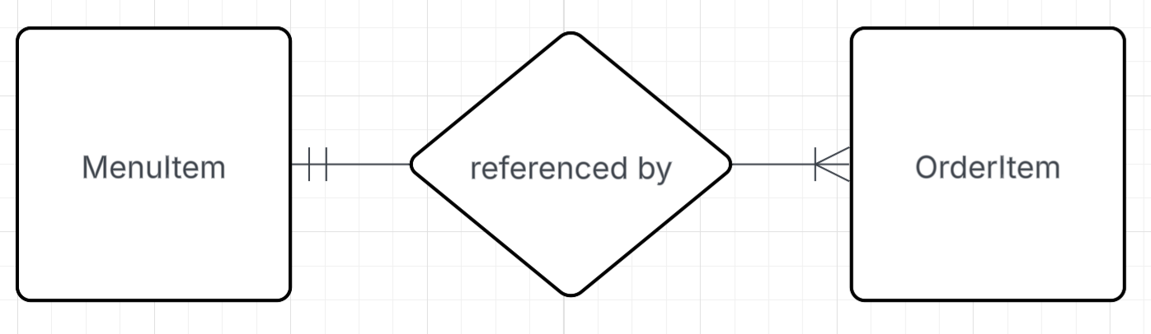
Final EDM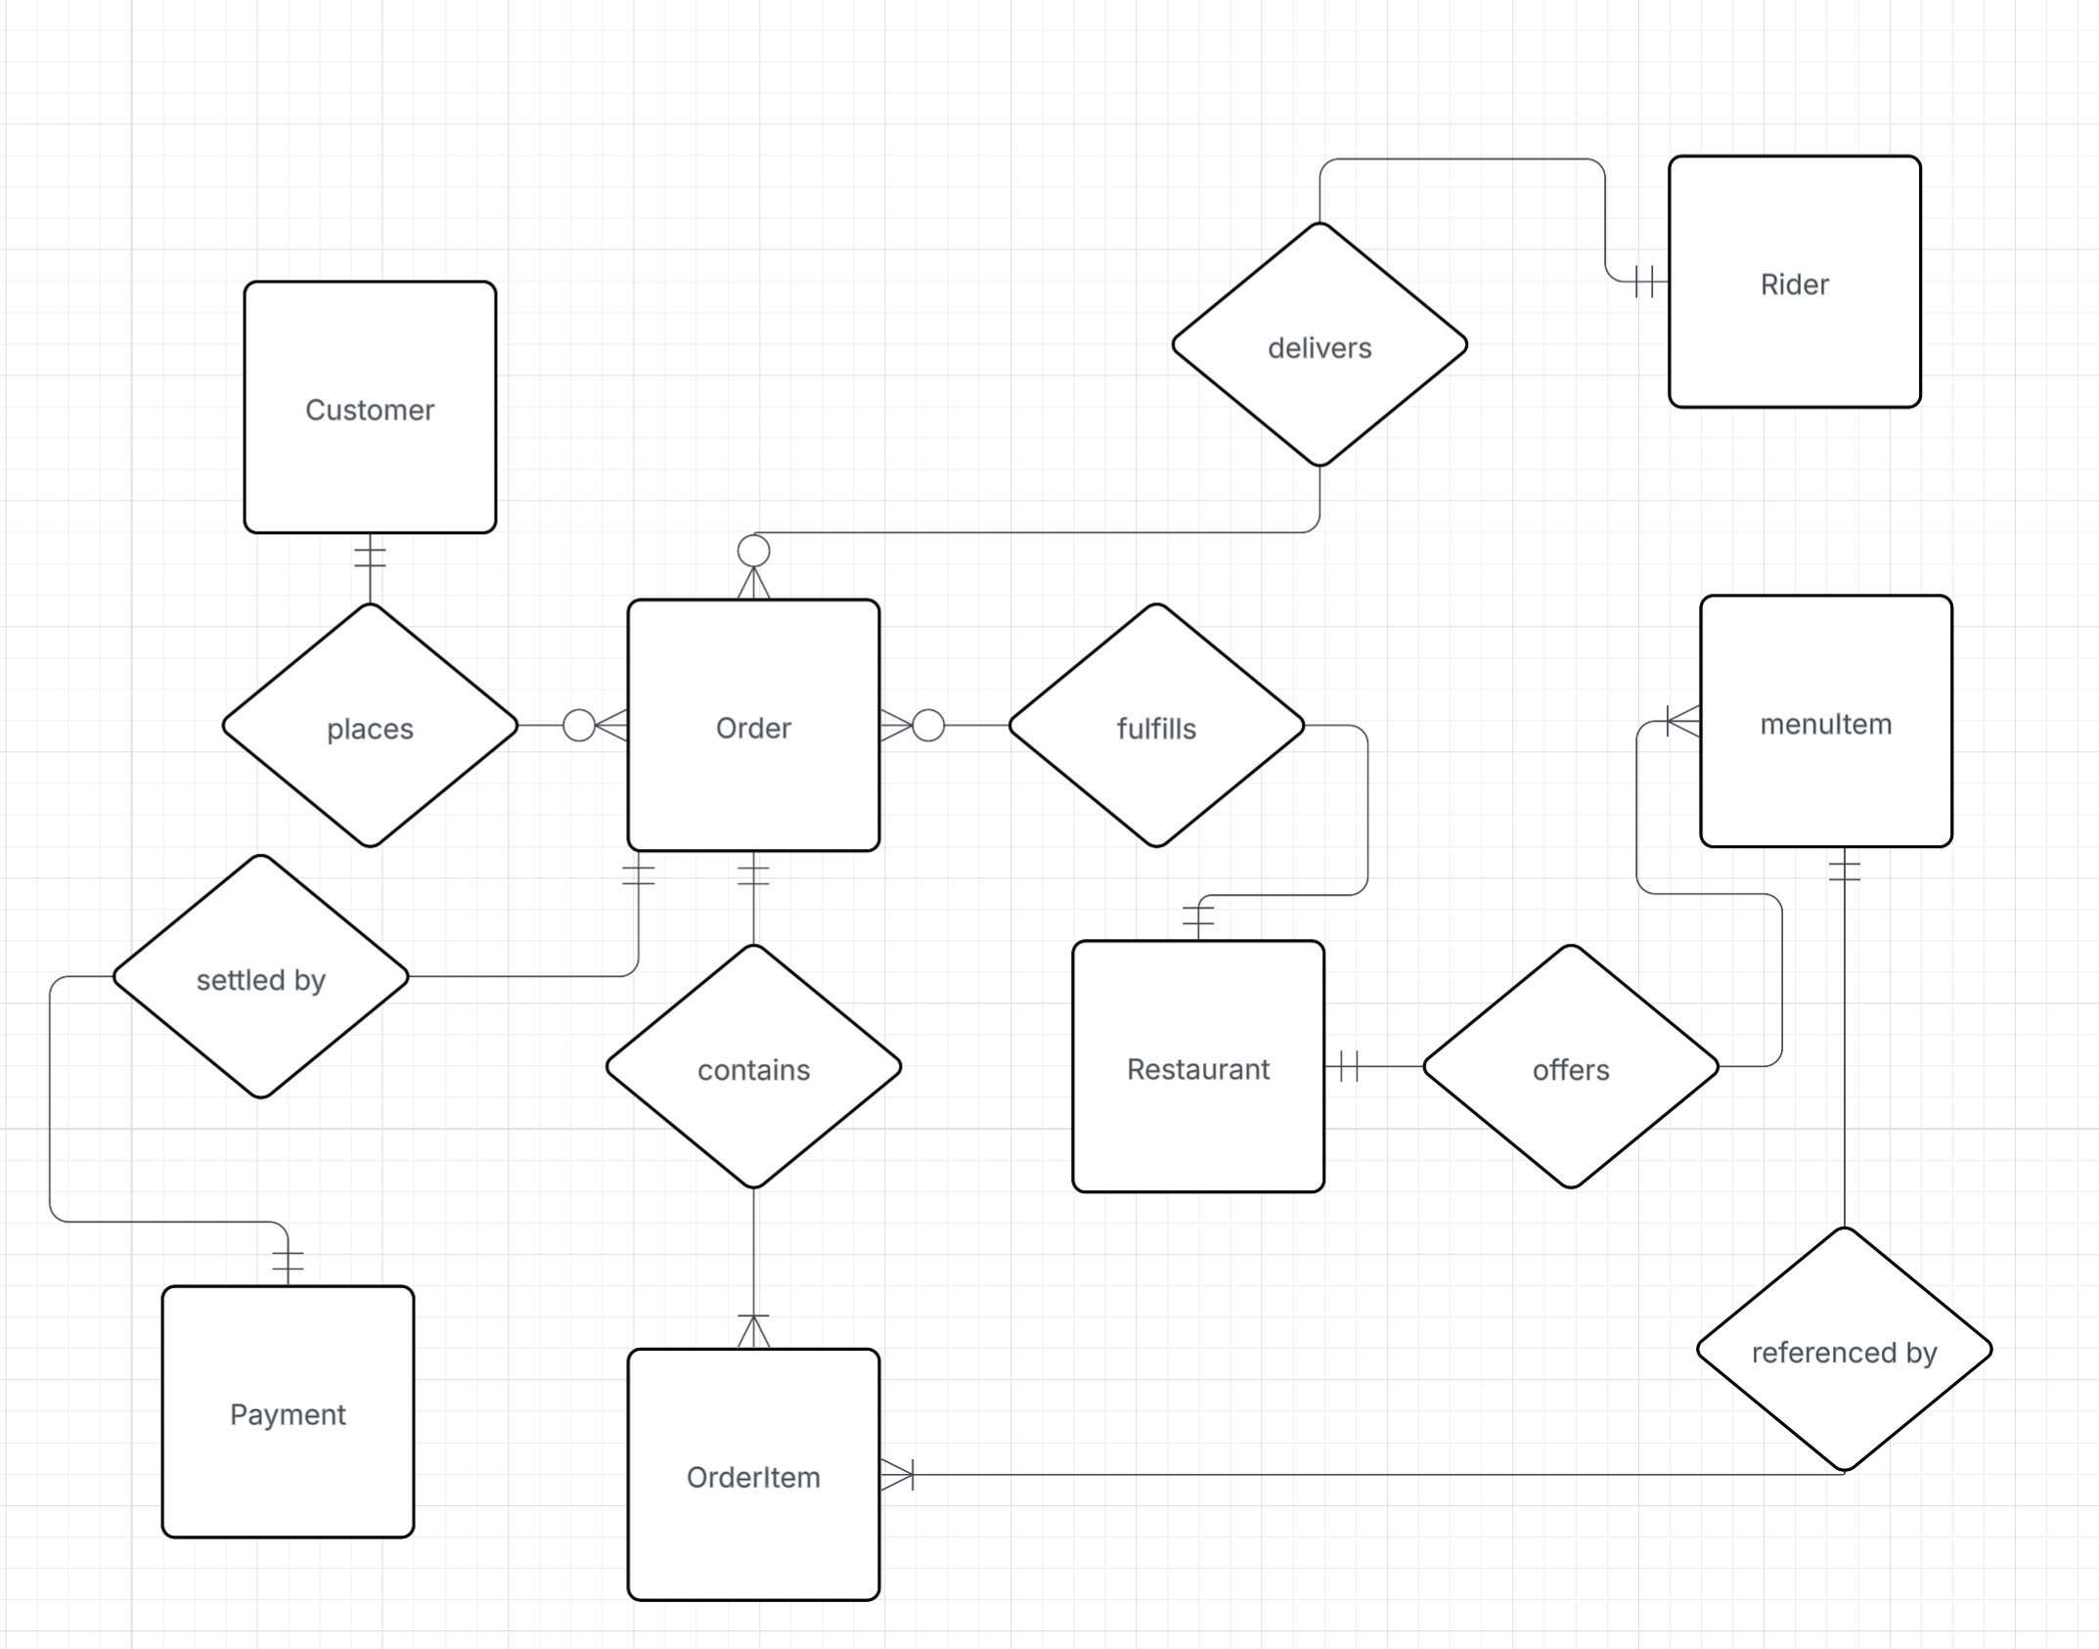

Entity Relationship Model:

Entities & Attributes
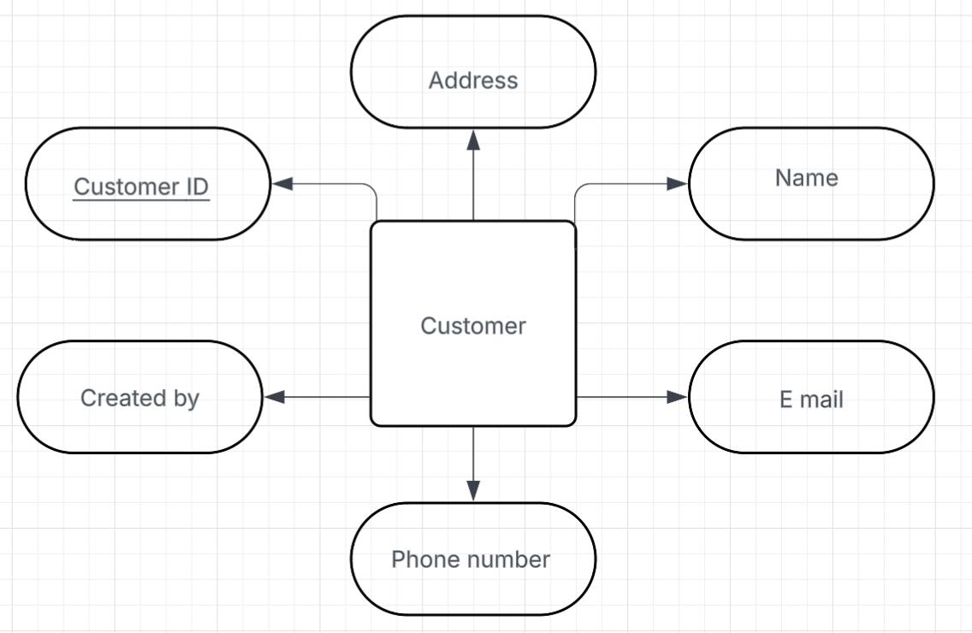

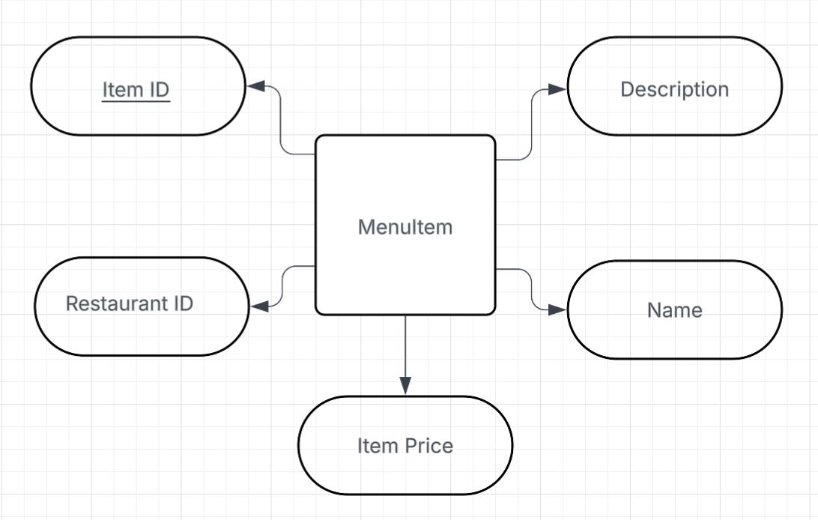

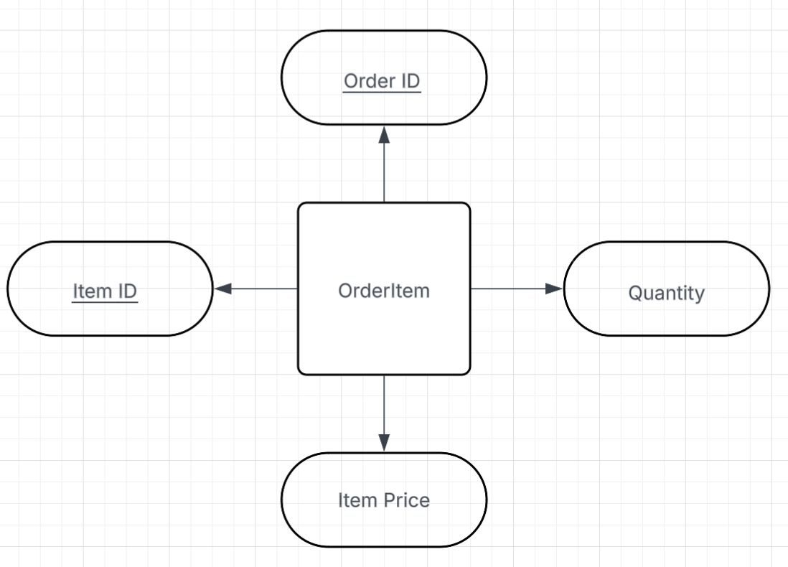

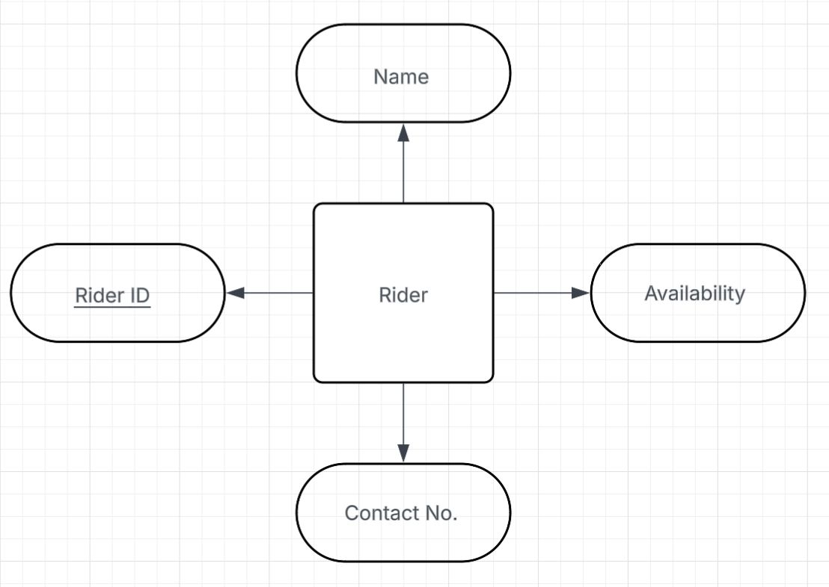

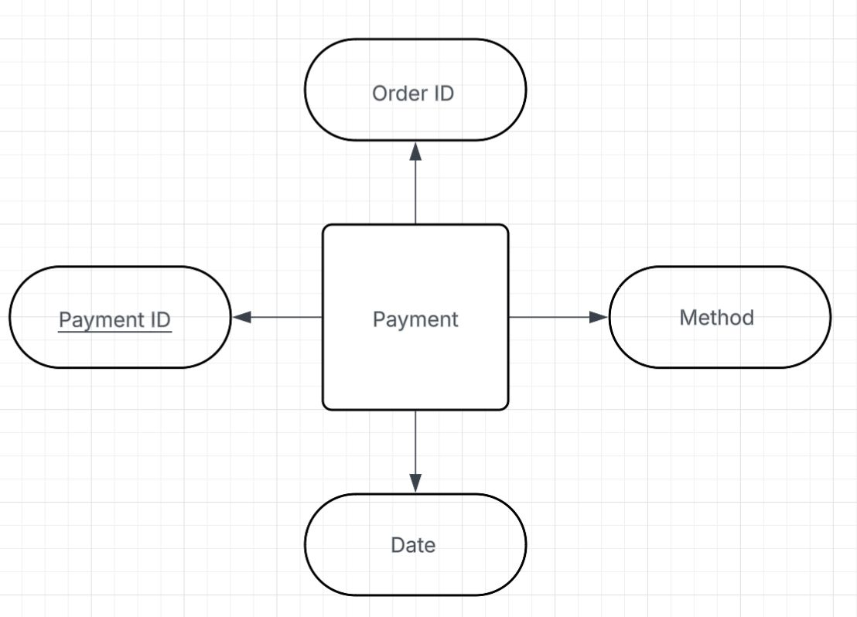

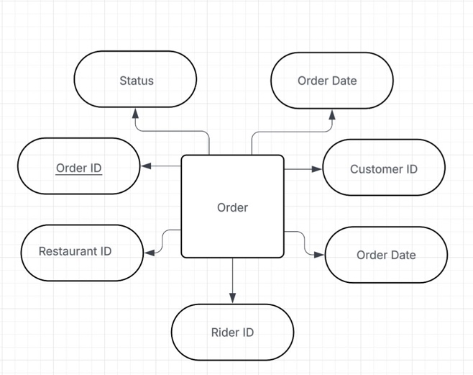

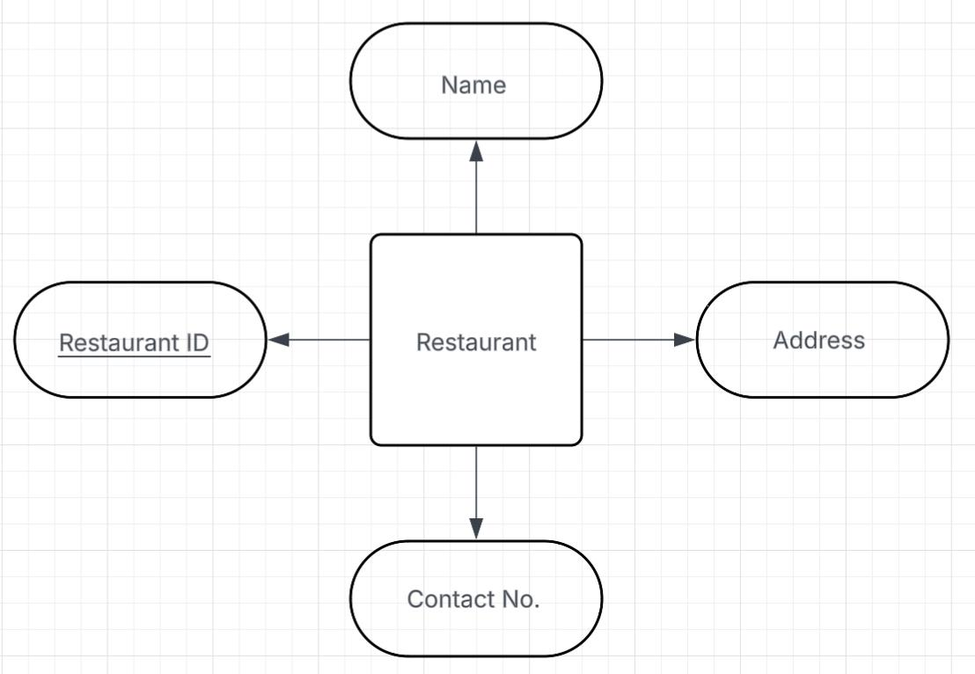

Relationships & Cardinality
  - Customer and Order
Customer - Places - Order
- A customer can place zero or many orders.
- An order must be placed by one and only one customer.

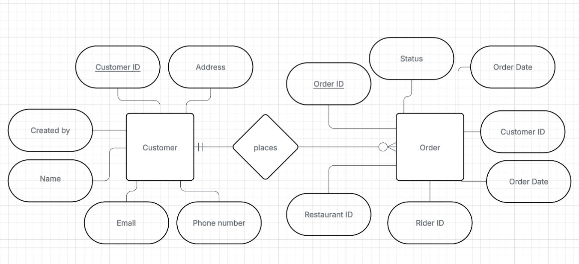

Restaurant and Order
Restaurant - Fulfills - Order
- A restaurant must fulfill zero or many orders.
- An order must be fulfilled by one and only one restaurant.
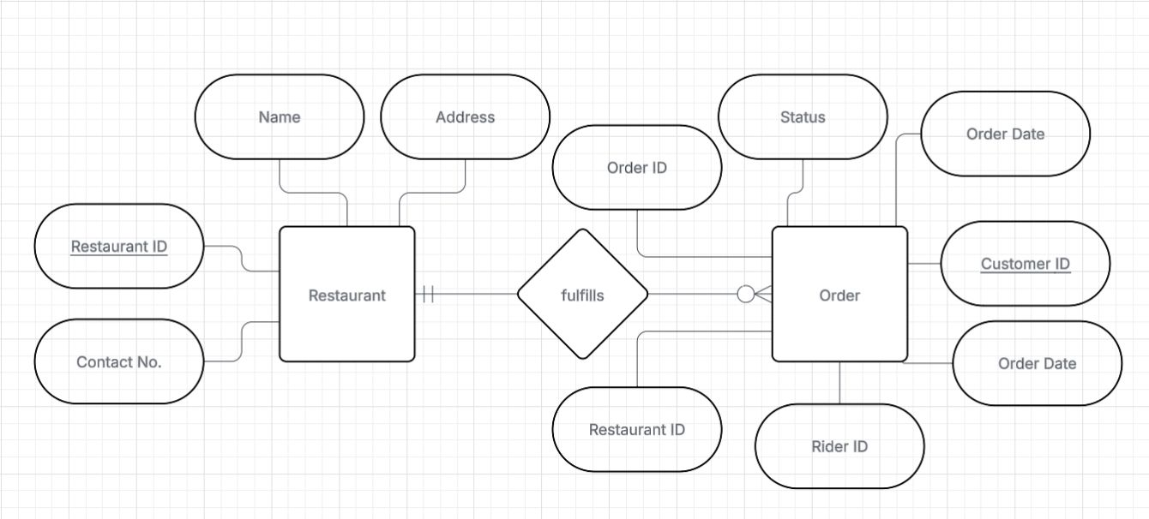

  - Rider and Order
Rider - Delivers - Order
- A rider can deliver zero or many orders.
- An order must be delivered by one and only one rider (once assigned).

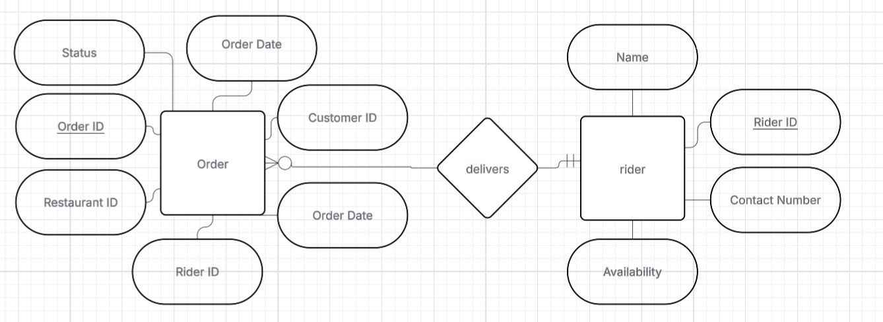
  - Order and Payment
Order - Settled By - Payment
- An order is settled by one and only one payment.
- A payment settles one and only one order.

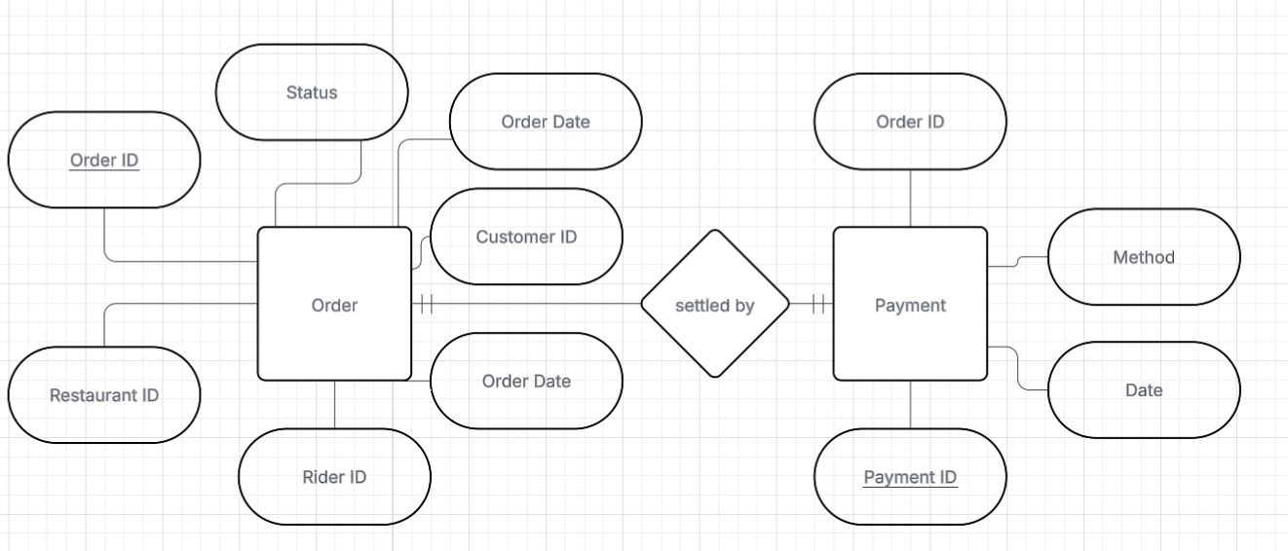

  - Restaurant and MenuItem (Product)
Restaurant - Offers - MenuItem
- A restaurant must offer one or many menu items.
- A menu item must be offered by one and only one restaurant.
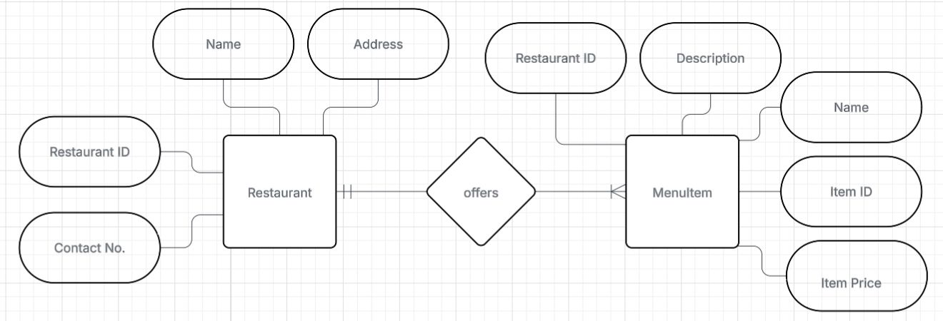

  - Order and OrderItem
Order - Contains - OrderItem
- An order must contain one or many order items (line items).
- An order item belongs to one and only one order.

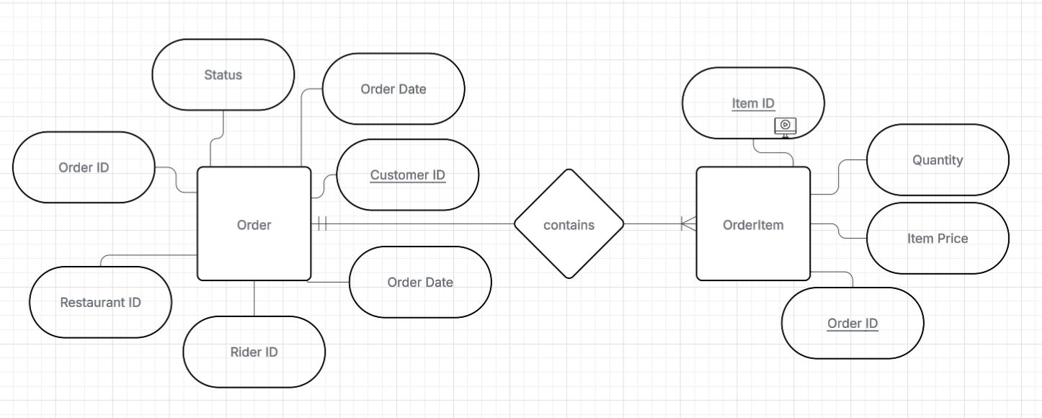

  - MenuItem and OrderItem
MenuItem - Referenced By - OrderItem
- A menu item must be referenced by one or many order items.
- An order item references one and only one menu item.
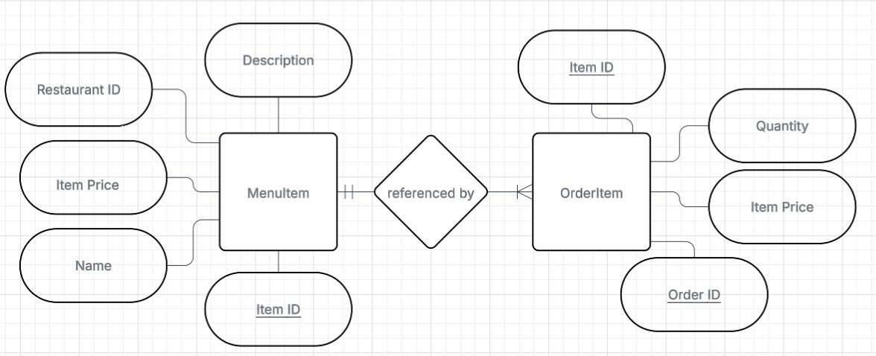

Final ER Diagram:
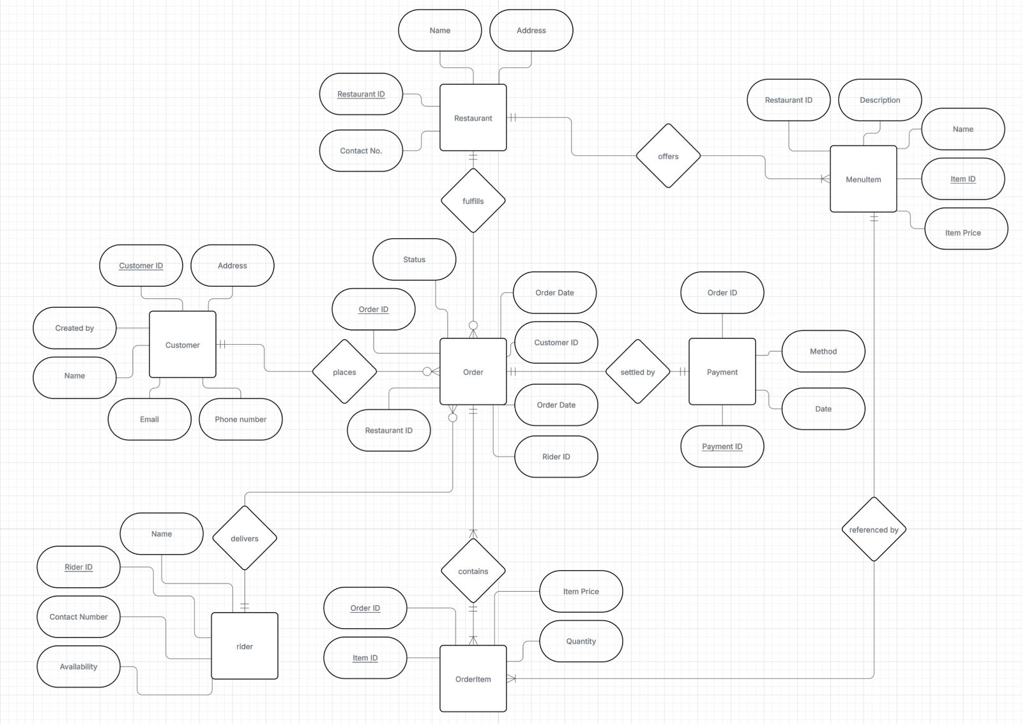
Description:
The most critical structural element in this ER model is the OrderItem entity, which functions as an associative entity to resolve the complex many-to-many relationship between Order and MenuItem. This entity interposes itself to create two manageable one-to-many relationships, making the system efficient and accurate. Its primary purpose is to hold transaction-specific details that belong to the purchase instance, not the item or the order alone. Specifically, it tracks:
- Quantity: How many of a single item were bought in that specific order.
- Price at Time of Order (Historical Price): The exact price paid, which prevents future menu price changes from corrupting past order records

Relational Model:

Entities Tables
  - Customer
Attributes | Optional/  Required | Single /  Composite | Simple/  Multi value | Stored/  Derived | Notes
Customer_ID | Required | Single | Simple | Stored | Primary Key
Name | Required | Composite  (first/last) | Simple | Stored
E_mail | Required | Single | Simple | Stored | Unique
Phone_NO | Required | Single | Multi value | Stored | Can be multiple
Created By | Required | Single | Simple | Stored | Date created
Address | Required | Single | Simple | Stored

  - Restaurant
Attributes | Optional/  Required | Single /  Composite | Simple /  Multi value | Stored/  Derived | Notes
Restaurant_ID | Required | Single | Simple | Stored | Primary Key
Name | Required | Single | Simple | Stored
Address | Required | Single | Simple | Stored
Contact NO | Required | Single | Simple | Stored
  - MenuItem
Attributes | Optinal/  Required | Simple/  Composite | Simple /  Multi value | Stored/  Derived | Notes
Item_ID(PK) | Required | Single | Simple | Stored | Primary Key
Restaurant_ID | Required | Single | Simple | Stored | Foreign Key
Name | Required | Single | Simple | Stored
Description | Optional | Single | Simple | Stored
Price | Required | Single | Simple | Stored
  - Rider
Attributes | Optinal/  Required | Simple/  Composite | Simple /  Multi value | Stored/  Derived | Notes
Rider_ID | Required | Single | Simple | Stored | Primary Key
Name | Required | Single | Simple | Stored
Contact NO | Required | Single | Simple | Stored
Availability | Required | Single | Simple | Stored | Boolean
  - Payment
Attributes | Optinal/  Required | Simple/  Composite | Simple /  Multi value | Stored/  Derived | Notes
Payment_ID | Required | Single | Simple | Stored | Primary Key
Order_ID | Required | Single | Simple | Stored | Foreign Key
Method | Required | Single | Simple | Stored
Date | Required | Single | Simple | Stored
  - Order
Attributes | Optional/  Required | Simple/  Composite | Simple /  Multi value | Stored/  Derived | Notes
Order_ID | Required | Single | Simple | Stored | Primary Key
Customer_ID | Required | Single | Simple | Stored | Foreign Key
Restaurant_ID | Required | Single | Simple | Stored | Foreign Key
Rider_ID | Optional | Single | Simple | Stored | Foreign Key
Order Date | Required | Single | Simple | Stored
Total Amount | Required | Single | Simple | Derived | From Order
Status | Required | Single | Simple | Stored
  - OrderItem(Associative Entity)
Attributes | Optinal/  Required | Simple/  Composite | Simple /  Multi value | Stored/  Derived | Notes
Order_ID(PK) | Required | Single | Simple | Stored | Foreign Key
Item_ID(PK) | Required | Single | Simple | Stored | Foreign Key
Quantity | Optional | Single | Simple | Stored
Item Price | Required | Single | Simple | Stored

Relational Tables
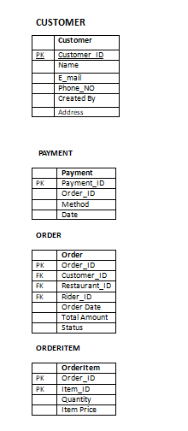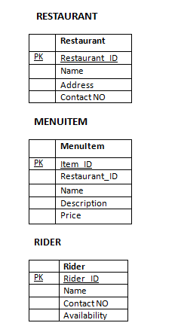

Relational Schema

Customer
Customer_ID | First Name | Last Name | E_mail | Phone No | Created At

Restaurant
Restaurant_ID | Name | Street | City | Contact No

Menu Item
Item_ID | Restaurant_ID | Name | Description | Price | Available

Rider
Rider_ID | Name | Contact No | Availability

Order
Order_ID | Customer_ID | Restaurant_ID | Rider_ID | Order Date | Total Amount | Status

Payment
Payment_ID | Order_ID | Method | Amount | Payment Date | Status

OrderItem
Order_ID | Item_ID | Quantity | Item price

Integrity Constraints
- Entity Integrity:
Enforced by PRIMARY KEY (PK must be UNIQUE and NOT NULL).
In our online food delivery system all the primary key are NOT NULL and UNIQUE.Like…
Customer_ID
Restaurant_ID
Item_ID
Rider_ID
Order_ID
Payment_ID
Order_ID+ Item_ID

- Domain Integrity:
Domain Integrity ensures that the values within a column are valid and conform to specific formats and constraints.
Some Common Entities attributes domain constraints:-
Customer.Email -> NVARCHAR(100) UNIQUE
Customer.CreatedAt -> DATETIME DEFAULT GETDATE()
Customer.Contact No -> NVARCHAR(20)
MenuItem.Price -> DECIMAL(10,2) (Implied: CHECK Price > 0)
MenuItem.Available -> BIT
Order.Status ->NVARCHAR(30) Restricted Values (ENUM/CHECK)
Order.Order Date -> DATETIME DEFAULT GETDATE()
Restaurant.Contact Number ->NVARCHAR(20)
Restaurant.Contact No -> NVARCHAR(20)
Rider.Contact No -> NVARCHAR(20)
- Referential Integrity:
Enforced by FOREIGN KEY (FKs reference existing PKs).
In our online food delivery system all Foreign key reference to existing Primary Key, shown in below final Relational Schema.

Final Relational Schema
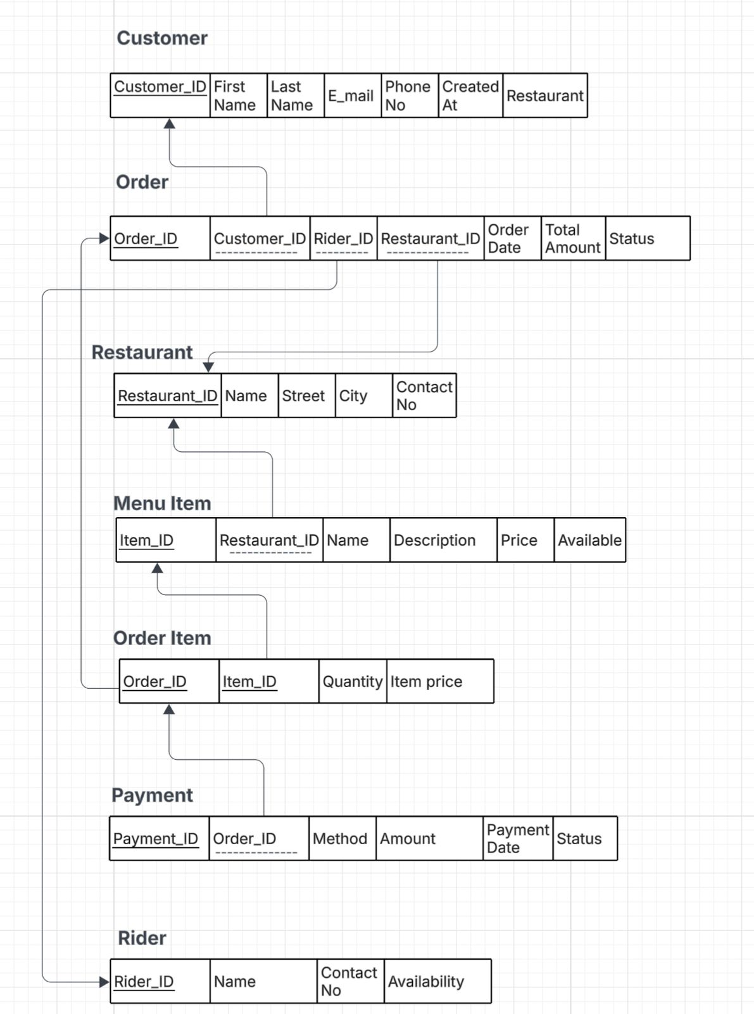

Normalization:

1. First Normal Form (1NF)
Rule: All attributes must be atomic (single-valued), and there must be no repeating groups or multi-valued columns.
Customer
Attributes | Optional/  Required | Single /  Composite | Simple/  Multi value | Stored/  Derived | Notes
Customer_ID | Required | Single | Simple | Stored | Primary Key
Name | Required | Composite  (first/last) | Simple | Stored
E_mail | Required | Single | Simple | Stored | Unique
Phone_NO | Required | Single | Multi value | Stored | Can be multiple
Created By | Required | Single | Simple | Stored | Date created
Address | Required | Single | Simple | Stored

In above mention customer table Phone_No is multivalue we convert this into simple like just contain one value in it.

Customer
Attributes | Optional/  Required | Single /  Composite | Simple/  Multi value | Stored/  Derived | Notes
Customer_ID | Required | Single | Simple | Stored | Primary Key
Name | Required | Composite  (first/last) | Simple | Stored
E_mail | Required | Single | Simple | Stored | Unique
Phone_NO | Required | Single | Simple | Stored | Cannot be multiple
Created By | Required | Single | Simple | Stored | Date created
Address | Required | Single | Simple | Stored

Now this entity attributes are atomic there is no violation of 1NF.
Repeating Groups
The multi-valued attributes for line items are resolved by the OrderItem table (the associative entity). This eliminates the need for repeating columns like Item1_ID, Item2_ID, ... in the Order table.

CONCLUSION:All the other Entities and their attributes are atomic and the use of separate tables for entities and the associative entity (OrderItem) ensures all relations are in 1NF so the system is in 1NF form.

2. Second Normal Form (2NF)
Rule: The relation must be in 1NF, and no non-key attribute can depend only on a part of a composite key (no partial dependencies).
Single-Key Tables
All tables(Entities) with a single primary key:-
- Customer Table with Attributes
(Customer_ID(PK),First Name,Last Name,E_mail,Phone_No,Created At)
- Restaurant Table with Attributes
(Restaurant_ID(PK),Name,Street,City,Contact_No)
- Rider Table with Attributes
(Rider_ID(PK),Name,Contact_No,Availability)
- Payment Table with Attributes
(Payment_ID(PK),Order_ID(FK),Method,,Amount,Payment Date,Status)
- Order Table with Attributes
(Order_ID(PK),Customer_ID(FK),Restaurant_ID(FK),Rider_ID(FK),Order Date, Total Amount,Status)
- MenuItem Table with Attributes
(Item_ID(PK),Restaurant_ID(FK),Name,Description,Price,Available)

RESULT:Since the PK is a single attribute, there is no "part" of the key for non-key attributes to partially depend on.

Composite-Key Table.
- OrderItem Table with Attributes
(Order_ID(PK)/(FK),Item_ID(PK)/(FK),Quantity,Item Price)

OrderItem has the composite key (OrderID + ItemID). Its non-key attributes are Quantity and Item Price

RESULT:Quantity and Item Price depend on the entire composite key. The price recorded is the historical price for that specific order instance (OrderID), making it dependent on the full key for transactional integrity. If it depended only on ItemID, it would violate 2NF but it donot violate it and Quantity also depend on both part of primary key.

CONCLUSION:From above explanation it is prove that system is in 2NF Form.

3. Third Normal Form (3NF)
Rule: The relation must be in 2NF, and no non-key attribute can depend on another non-key attribute (no transitive dependencies).
All Entities with attributes:-
- Customer Table with Attributes
(Customer_ID(PK),First Name,Last Name,E_mail,Phone_No,Created At)
Validation:All attributes depend only on CustomerID. No non-key attribute depends on another non-key attribute (e.g., Phone No does not determine First Name).

- Restaurant Table with Attributes
(Restaurant_ID(PK),Name,Street,City,Contact_No)
Validation: All attributes depend only on RestaurantID. Descriptors are correctly placed here.
- Rider Table with Attributes
(Rider_ID(PK),Name,Contact_No,Availability)
Validation: All attributes depend only on RiderID. This prevents descriptive rider data from being redundantly stored in the Order table.
- Payment Table with Attributes
(Payment_ID(PK),Order_ID(FK),Method,,Amount,Payment Date,Status)
Validation: All attributes depend solely on Payment_ID. The Order_ID (FK) links to the related order, but no other order details are stored here.
- Order Table with Attributes
(Order_ID(PK),Customer_ID(FK),Restaurant_ID(FK),Rider_ID(FK),Order Date, Total Amount,Status)
Validation: All Foreign Keys and descriptive attributes (Date, Total Amount, Status) depend only on the OrderID. Descriptive details about the Customer, Restaurant, or Rider are correctly isolated in their own tables.
- MenuItem Table with Attributes
(Item_ID(PK),Restaurant_ID(FK),Name,Description,Price,Available)
Validation: All non-key attributes depend solely on ItemID. The RestaurantID (FK) identifies the restaurant the item belongs to, but no other descriptive restaurant data is stored here.
- OrderItem Table with Attributes
(Order_ID(PK)/(FK),Item_ID(PK)/(FK),Quantity,Item Price)
Validation: Since this table already satisfied 2NF, and its non-key attributes are fully dependent on the composite key, there are no transitive dependencies present.
CONCLUSION:From above Explanation it is proved that our system is in 3NF.

Normalization Scenario
In this scenario we consider just one table and make it normalize.This table contain information about order,rider,menuitem and orderitem for our system.
Order_Master_Details
Attributes | Description
Order_ID | Primary Key(PK)
Item_ID | Primary Key(PK)
Quantity
Item Price
Item name
Item Description
Customer_ID | Foreign Key(FK)
Restaurant_ID | Foreign Key(FK)
Rider_ID | Foreign Key(FK)
Order Date
Total Amount
Order Status
Rider Name
Contact NO
Availability

Normalizing to Second Normal Form (2NF)
Rule: Remove all partial dependencies.
The attributes Item Name, Description, and Item Price depend only on ItemID. We separate them to create the MenuItem table.

Now our final 2 tables will be:-
Order_Master_Details
Attributes | Description
Order_ID | Primary Key(PK)
Item_ID | Primary Key(PK)
Quantity
Item Price
Item name
Item Description
Customer_ID | Foreign Key(FK)
Restaurant_ID | Foreign Key(FK)
Rider_ID | Foreign Key(FK)
Order Date
Total Amount
Order Status
Rider Name
Contact NO
Availability

Menuitem
Attributes | Description
Item_ID | Primary Key(PK)
Item Price
Item name
Item Description

This new table contain just detail relevant to menuitem in which Item_ID is PK.
The same Item_ID is FK in Order_Master_Details Table.

Normalizing to Third Normal Form (3NF)
Rule: Remove all transitive dependencies.
The attributes Rider Name, Rider Contact No, and Availability depend on the non-key attribute RiderID. We separate them to create the Rider table.
The remaining Order_Details table is then split into the main Order table and the associative OrderItem table.

Order_Master_Details
Attributes | Description
Order_ID | Primary Key(PK)
Item_ID | Primary Key(PK)
Quantity
Item Price
Item name
Item Description
Customer_ID | Foreign Key(FK)
Restaurant_ID | Foreign Key(FK)
Rider_ID | Foreign Key(FK)
Order Date
Total Amount
Order Status
Rider Name
Contact NO
Availability

Now our final 3 tables will be:-
Order
Attributes | Description
Order_ID | Primary Key(PK)
Customer_ID | Foreign Key(FK)
Restaurant_ID | Foreign Key(FK)
Rider_ID | Foreign Key(FK)
Order Date
Total Amount
Order Status

OrderItem
Attributes | Description
Order_ID | Primary Key(PK)
Item_ID | Primary Key(PK)
Quantity
Item Price

Rider
Attributes | Description
Rider_ID | Primary Key(PK)
Rider Name
Contact NO
Availability

CONCLUSION:Then we convert Order_Master_Details table into four (Menuitem,Order,Orderitem,Order) tables due to which all transitive and partial dependency is removed and our system is in 2NF and 3NF.

SQL Code

Database Setup
-- CREATE DATABASE FoodserviceDB;

--GO

USE FoodserviceDB;

GO

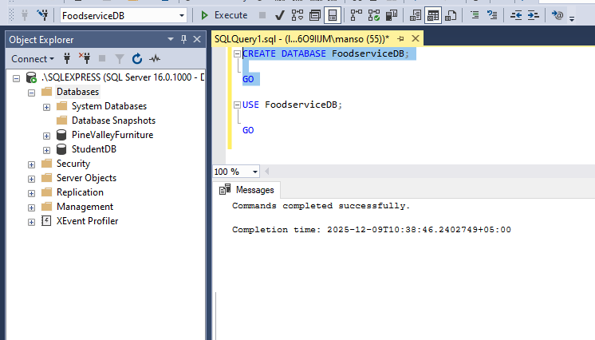

TABLES
CUSTOMER TABLE

CREATE TABLE Customer (
CustomerID INT IDENTITY(2001,1) PRIMARY KEY,
FirstName NVARCHAR(50),
LastName NVARCHAR(50),
Email NVARCHAR(100) UNIQUE,
PhoneNumber NVARCHAR(20),
CreatedAt DATETIME DEFAULT GETDATE()
);
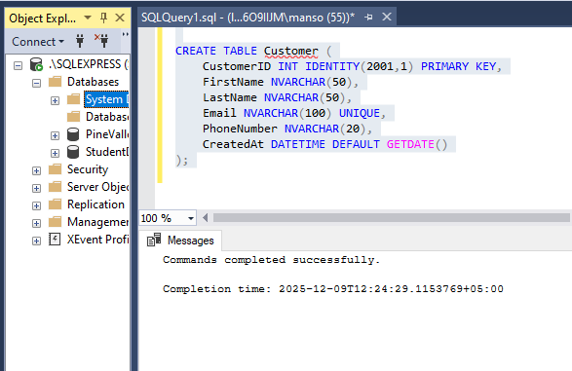

RESTAURANT TABLE
CREATE TABLE Restaurant (
RestaurantID INT IDENTITY(3001,1) PRIMARY KEY,
Name NVARCHAR(100),
Street NVARCHAR(100),
City NVARCHAR(50),
ContactNumber NVARCHAR(20)
); 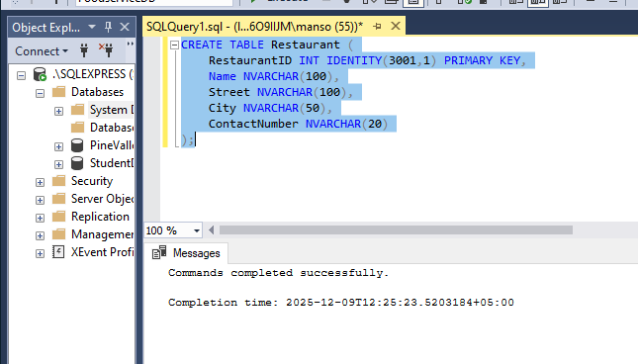

MENU ITEM TABLE
CREATE TABLE MenuItem (
ItemID INT IDENTITY(4001,1) PRIMARY KEY,
RestaurantID INT NOT NULL,
Name NVARCHAR(100),
Description NVARCHAR(255),
Price DECIMAL(10,2),
Available BIT,
CONSTRAINT FK_MenuItem_Restaurant FOREIGN KEY (RestaurantID) REFERENCES Restaurant(RestaurantID)
);

RIDER TABLE
CREATE TABLE Rider (
RiderID INT IDENTITY(5001,1) PRIMARY KEY,
Name NVARCHAR(100),
ContactNumber NVARCHAR(20),
Availability BIT
);

ORDER TABLE
CREATE TABLE [Order] (
OrderID INT IDENTITY(6001,1) PRIMARY KEY,
CustomerID INT NOT NULL,
RestaurantID INT NOT NULL,
RiderID INT NOT NULL,
OrderDate DATETIME DEFAULT GETDATE(),
Status NVARCHAR(30),
CONSTRAINT FK_Order_Customer FOREIGN KEY (CustomerID) REFERENCES Customer(CustomerID),
CONSTRAINT FK_Order_Restaurant FOREIGN KEY (RestaurantID) REFERENCES Restaurant(RestaurantID),
CONSTRAINT FK_Order_Rider FOREIGN KEY (RiderID) REFERENCES Rider(RiderID)
);

ORDER ITEM TABLE
CREATE TABLE OrderItem (
OrderID INT NOT NULL,
ItemID INT NOT NULL,
Quantity INT,
PRIMARY KEY (OrderID, ItemID),
CONSTRAINT FK_OrderItem_Order FOREIGN KEY (OrderID) REFERENCES [Order](OrderID),
CONSTRAINT FK_OrderItem_MenuItem FOREIGN KEY (ItemID) REFERENCES MenuItem(ItemID)
);

PAYMENT TABLE
CREATE TABLE Payment (
PaymentID INT IDENTITY(7001,1) PRIMARY KEY,
OrderID INT NOT NULL,
Method NVARCHAR(30),
Amount DECIMAL(10,2),
PaymentDate DATETIME DEFAULT GETDATE(),
Status NVARCHAR(30),
CONSTRAINT FK_Payment_Order FOREIGN KEY (OrderID) REFERENCES [Order](OrderID)
);

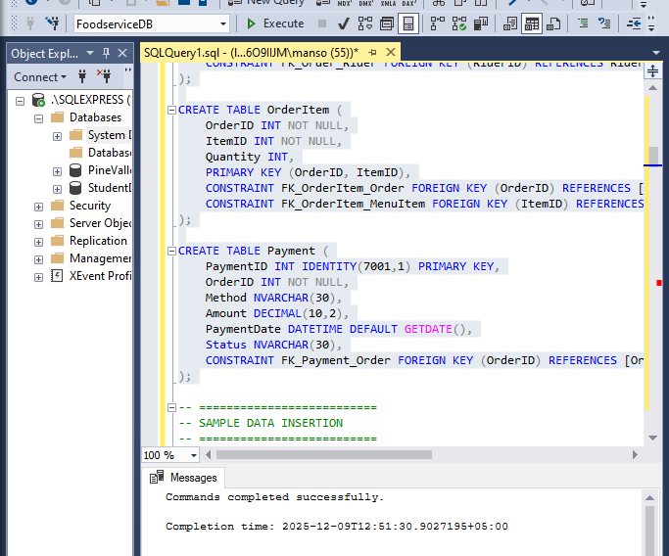

Data Insertion

Customers
INSERT INTO Customer (FirstName, LastName, Email, PhoneNumber)
VALUES
('Ali','Raza','ali1@example.com','03001111111'),
('Sara','Khan','sara2@example.com','03002222222'),
('Hamza','Malik','hamza3@example.com','03003333333'),
('Ayesha','Sheikh','ayesha4@example.com','03004444444'),
('Bilal','Ahmed','bilal5@example.com','03005555555'),
('Fatima','Javed','fatima6@example.com','03006666666'),
('Usman','Butt','usman7@example.com','03007777777'),
('Zain','Ali','zain8@example.com','03008888888'),
('Hira','Saleem','hira9@example.com','03009999999'),
('Taha','Rafay','taha10@example.com','03110000001'),
('Rimsha','Shah','rimsha11@example.com','03110000002'),
('Fahad','Khalid','fahad12@example.com','03110000003'),
('Noor','Iqbal','noor13@example.com','03110000004'),
('Danish','Hanif','danish14@example.com','03110000005'),
('Sadaf','Zahid','sadaf15@example.com','03110000006'); 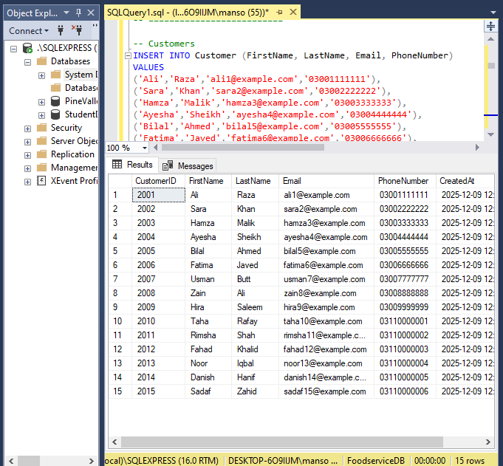

Restaurants
INSERT INTO Restaurant (Name, Street, City, ContactNumber)
VALUES
('Pizza Palace','Main Road','Islamabad','0511111111'),
('Burger Hub','Blue Area','Islamabad','0512222222'),
('Biryani House','Saddar','Rawalpindi','0513333333'),
('Food Street Café','G-9','Islamabad','0514444444'),
('Tikka Junction','F-10','Islamabad','0515555555'),
('Karachi Bites','F-11','Islamabad','0516666666'),
('Rolling Pizza','Gulshan Road','Karachi','0211111111'),
('BBQ Tonight','Clifton','Karachi','0212222222'),
('Shawarma King','Johar Town','Lahore','0421111111'),
('Lahore Grill','Model Town','Lahore','0422222222'),
('Pasta Point','DHA Phase 2','Karachi','0213333333'),
('Kebab Villa','Bahria Town','Rawalpindi','0517777777'),
('Noodle Express','I-8','Islamabad','0518888888'),
('Zinger Stop','G-11','Islamabad','0519999999'),
('Fry Master','G-6','Islamabad','0511212121');



Menu Items
INSERT INTO MenuItem (RestaurantID, Name, Description, Price, Available)
VALUES
(3001,'Pepperoni Pizza','Large pepperoni pizza',1200,1),
(3002,'Zinger Burger','Crispy zinger with fries',550,1),
(3003,'Chicken Biryani','Spicy biryani plate',250,1),
(3004,'Club Sandwich','Triple layer sandwich',450,1),
(3005,'Beef Tikka','Charcoal grilled tikka',700,1),
(3006,'Chicken Roll','Paratha roll with sauce',180,1),
(3007,'Cheese Pizza','12-inch cheese pizza',999,1),
(3008,'BBQ Platter','Mix grill platter',1800,1),
(3009,'Chicken Shawarma','Lebanese style shawarma',250,1),
(3010,'Beef Karahi','Traditional karahi',1500,1),
(3011,'Fettuccine Alfredo','Creamy pasta bowl',850,1),
(3012,'Seekh Kebab','2-piece spicy kebab',300,1),
(3013,'Chicken Chow Mein','Chinese noodles',450,1),
(3014,'Zinger Shawarma','Zinger meat with sauces',300,1),
(3015,'French Fries','Crispy fries',150,1);

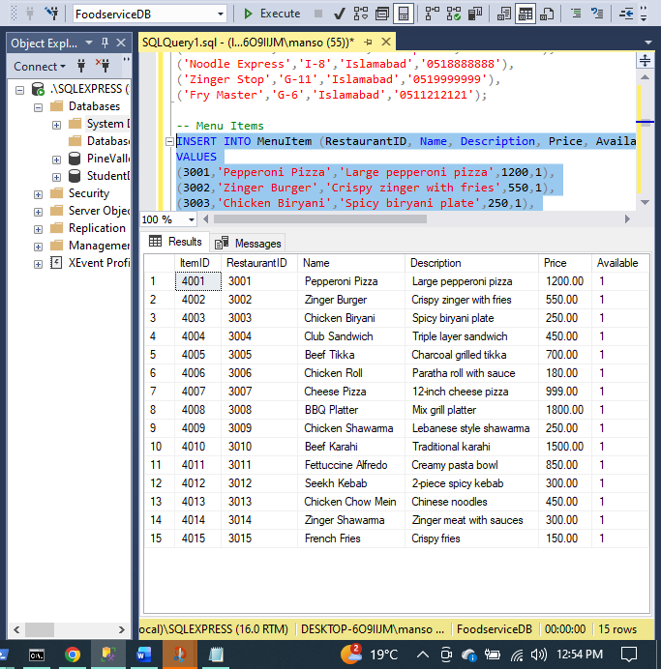
Riders
INSERT INTO Rider (Name, ContactNumber, Availability)
VALUES
('Ahmed','03450000001',1),
('Bilal','03450000002',1),
('Usman','03450000003',1),
('Hamza','03450000004',1),
('Sajid','03450000005',1),
('Jawad','03450000006',1),
('Tariq','03450000007',1),
('Ali Shan','03450000008',1),
('Noman','03450000009',1),
('Hussain','03450000010',1),
('Adeel','03450000011',1),
('Kashif','03450000012',1),
('Raza','03450000013',1),
('Daniyal','03450000014',1),
('Hammad','03450000015',1);
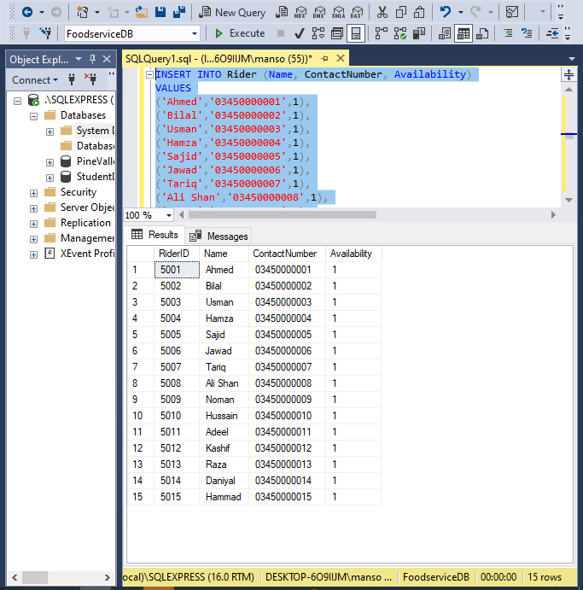

orders
INSERT INTO [Order] (CustomerID, RestaurantID, RiderID, Status)
VALUES
(2001,3001,5001,'Delivered'),
(2002,3002,5002,'Pending'),
(2003,3003,5003,'Preparing'),
(2004,3004,5004,'Delivered'),
(2005,3005,5005,'Pending'),
(2006,3006,5006,'Preparing'),
(2007,3007,5007,'Delivered'),
(2008,3008,5008,'Pending'),
(2009,3009,5009,'Preparing'),
(2010,3010,5010,'Delivered'),
(2011,3011,5011,'Pending'),
(2012,3012,5012,'Preparing'),
(2013,3013,5013,'Delivered'),
(2014,3014,5014,'Pending'),
(2015,3015,5015,'Delivered');

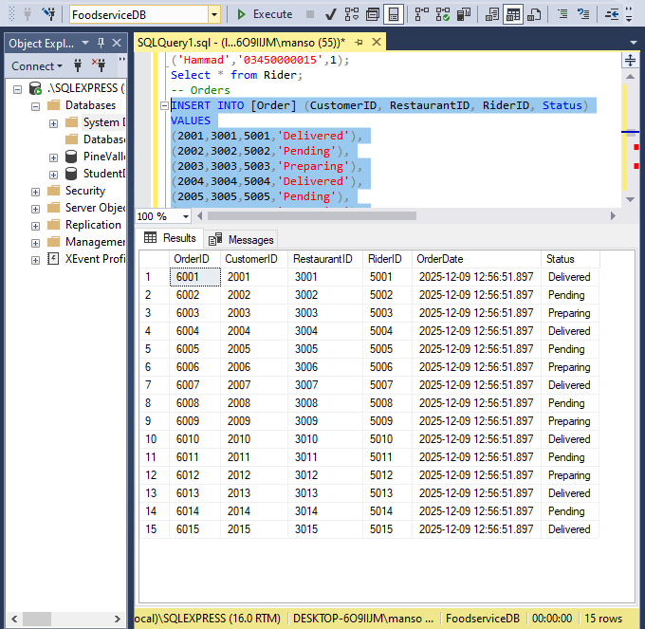

OrderItem
INSERT INTO OrderItem (OrderID, ItemID, Quantity)
VALUES
(6001,4001,2),(6002,4002,1),(6003,4003,3),(6004,4004,2),(6005,4005,1),
(6006,4006,2),(6007,4007,1),(6008,4008,3),(6009,4009,2),(6010,4010,1),
(6011,4011,2),(6012,4012,1),(6013,4013,2),(6014,4014,1),(6015,4015,2);

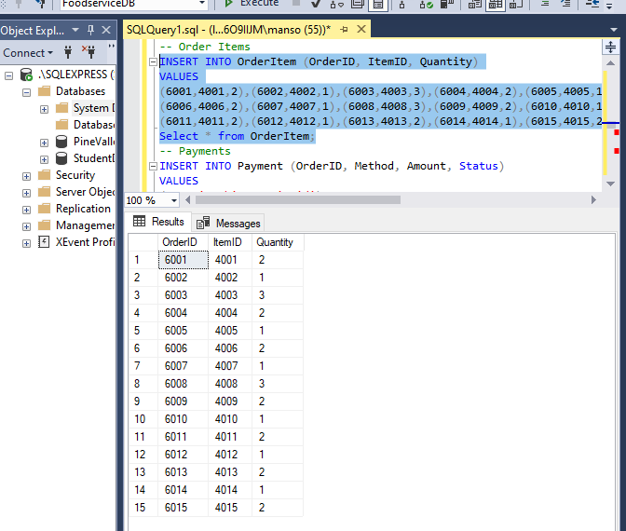
Payments
INSERT INTO Payment (OrderID, Method, Amount, Status)
VALUES
(6001,'Cash',2400,'Paid'),
(6002,'Credit Card',550,'Pending'),
(6003,'Cash',750,'Paid'),
(6004,'Easypaisa',450,'Paid'),
(6005,'Cash',700,'Pending'),
(6006,'JazzCash',360,'Paid'),
(6007,'Credit Card',999,'Paid'),
(6008,'Cash',1800,'Pending'),
(6009,'Cash',250,'Paid'),
(6010,'Credit Card',1500,'Pending'),
(6011,'Cash',850,'Paid'),
(6012,'Credit Card',300,'Pending'),
(6013,'JazzCash',450,'Paid'),
(6014,'Cash',300,'Paid'),
(6015,'Easypaisa',150,'Pending');
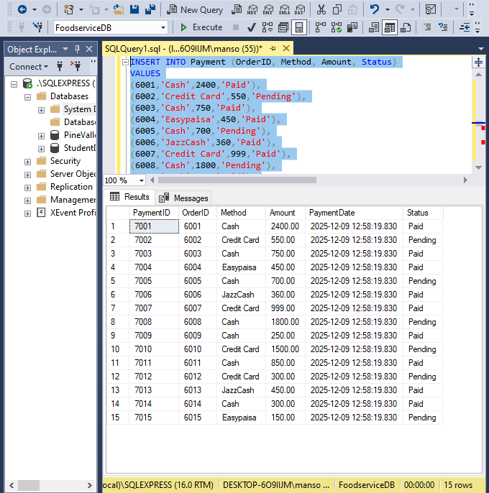
Table Name | ID Column | Starts From
Customer | CustomerID | 2001
Restaurant | RestaurantID | 3001
MenuItem | ItemID | 4001
Rider | RiderID | 5001
Order | OrderID | 6001
OrderItem | (composite PK) | Follows OrderID + ItemID FK references
Payment | PaymentID | 7001

Users, Roles, and Access Control (DCL)
USE master;
GO

-- Create SQL Server Logins (for app login)
-- Each user type can log in through its own account
CREATE LOGIN CustomerLogin WITH PASSWORD = 'Customer@123';
CREATE LOGIN RiderLogin WITH PASSWORD = 'Rider@123';
CREATE LOGIN RestaurantLogin WITH PASSWORD = 'Restaurant@123';
CREATE LOGIN AdminLogin WITH PASSWORD = 'Admin@123';
GO

-- Create database users inside FoodserviceDB
USE FoodserviceDB;
GO

CREATE USER CustomerUser FOR LOGIN CustomerLogin;
CREATE USER RiderUser FOR LOGIN RiderLogin;
CREATE USER RestaurantUser FOR LOGIN RestaurantLogin;
CREATE USER AdminUser FOR LOGIN AdminLogin;
GO

--Create Roles
CREATE ROLE Customer_Role;
CREATE ROLE Rider_Role;
CREATE ROLE Restaurant_Manager_Role;
CREATE ROLE Admin_Role;
GO

--Assign Permissions to Roles

-- Admin Role: Full access
GRANT SELECT, INSERT, UPDATE, DELETE ON Customer TO Admin_Role;
GRANT SELECT, INSERT, UPDATE, DELETE ON Restaurant TO Admin_Role;
GRANT SELECT, INSERT, UPDATE, DELETE ON MenuItem TO Admin_Role;
GRANT SELECT, INSERT, UPDATE, DELETE ON Rider TO Admin_Role;
GRANT SELECT, INSERT, UPDATE, DELETE ON [Order] TO Admin_Role;
GRANT SELECT, INSERT, UPDATE, DELETE ON OrderItem TO Admin_Role;
GRANT SELECT, INSERT, UPDATE, DELETE ON Payment TO Admin_Role;

-- Restaurant Manager Role: Manage menu & restaurant info
GRANT SELECT, INSERT, UPDATE ON MenuItem TO Restaurant_Manager_Role;
GRANT SELECT, UPDATE ON Restaurant TO Restaurant_Manager_Role;

-- Rider Role: Can view orders & update own availability
GRANT SELECT ON [Order] TO Rider_Role;
GRANT UPDATE ON Rider TO Rider_Role;

-- Customer Role: Read-only access to restaurants, menu, and own orders
GRANT SELECT ON Restaurant TO Customer_Role;
GRANT SELECT ON MenuItem TO Customer_Role;
GRANT SELECT ON [Order] TO Customer_Role;
GO

--Assign Users to Roles
ALTER ROLE Customer_Role ADD MEMBER CustomerUser;
ALTER ROLE Rider_Role ADD MEMBER RiderUser;
ALTER ROLE Restaurant_Manager_Role ADD MEMBER RestaurantUser;
ALTER ROLE Admin_Role ADD MEMBER AdminUser;
GO
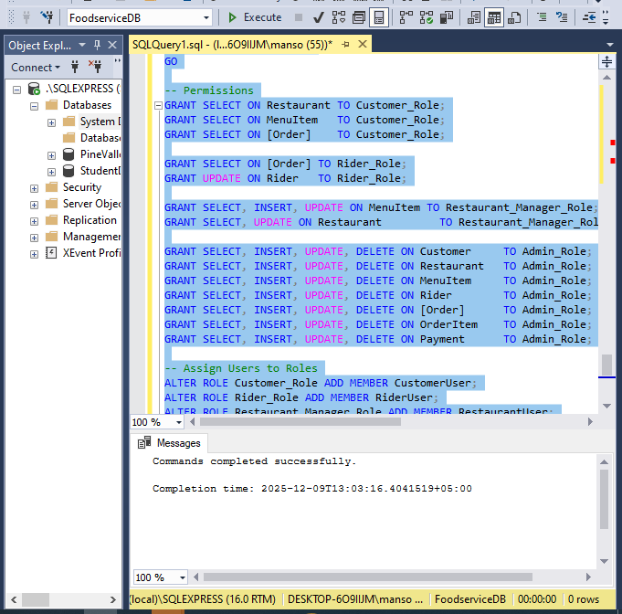

TRIGGERS
1.Auto-update Rider Availability when Order Delivered
- Automatically updates the assigned Rider's Availability to 1 whenever the associated order's Status is changed to 'Delivered'.
- Enforces the business logic that a rider is immediately available for a new dispatch once their current delivery is completed.

CREATE TRIGGER trg_UpdateRiderAvailability
ON [Order]
AFTER UPDATE
AS
BEGIN
IF UPDATE(Status)
BEGIN
UPDATE Rider
SET Availability = 1
FROM Rider r
JOIN inserted i ON r.RiderID = i.RiderID
WHERE i.Status = 'Delivered';
END
END;
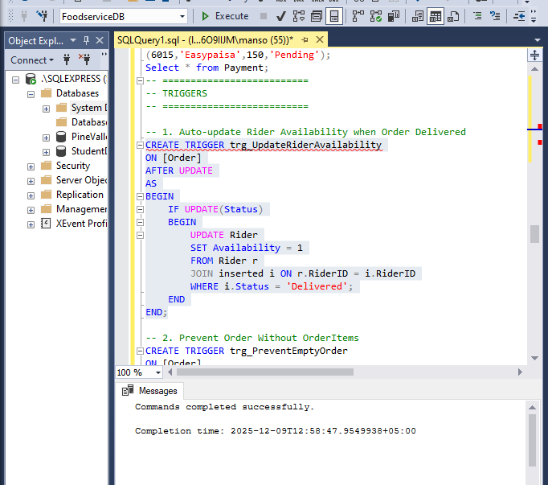

2.Prevent Order Without OrderItems
- An AFTER INSERT validation check that ensures a newly created Order record has at least one corresponding entry in the OrderItem table.
- Prevents the commitment of invalid or meaningless orders by rolling back the entire transaction if the order has no line items.

CREATE TRIGGER trg_PreventEmptyOrder
ON [Order]
AFTER INSERT
AS
BEGIN
IF NOT EXISTS (
SELECT 1 FROM OrderItem WHERE OrderID IN (SELECT OrderID FROM inserted)
)
BEGIN
RAISERROR('Order must have at least 1 Order Item!', 16, 1);
ROLLBACK TRANSACTION;
END
END;

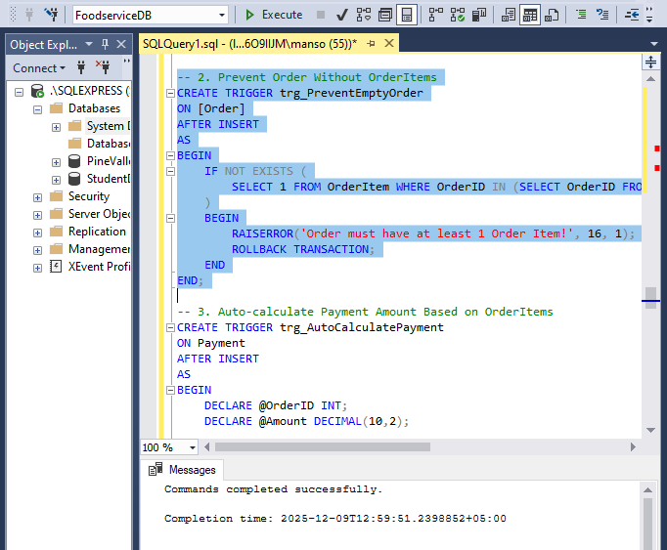
3.Auto-calculate Payment Amount Based on OrderItems
- Automatically calculates the final Amount for a new Payment record by summing the total cost (Quantity * ItemPrice) from all related OrderItem records.
- Guarantees financial consistency and prevents manual data entry errors by ensuring the payment amount always matches the exact order total.

CREATE TRIGGER trg_AutoCalculatePayment
ON Payment
AFTER INSERT
AS
BEGIN
DECLARE @OrderID INT;
DECLARE @Amount DECIMAL(10,2);

SELECT @OrderID = OrderID FROM inserted;

SELECT @Amount = SUM(Quantity * Price)
FROM OrderItem oi
JOIN MenuItem mi ON oi.ItemID = mi.ItemID
WHERE oi.OrderID = @OrderID;

UPDATE Payment
SET Amount = @Amount
WHERE OrderID = @OrderID;
END;
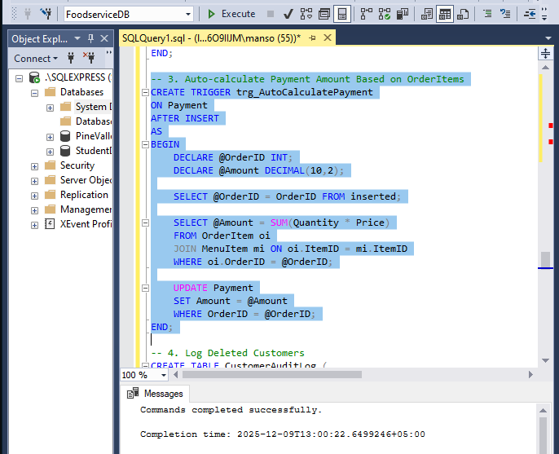

4.Log Deleted Customers
- A crucial auditing mechanism that fires AFTER DELETE on the Customer table, capturing the deleted record's details (CustomerID, Email).
- Maintains a mandatory, non-repudiable Audit Log of all removed customer accounts for historical tracking and compliance.

Create audit table:
CREATE TABLE CustomerAuditLog (
LogID INT IDENTITY(1,1) PRIMARY KEY,
CustomerID INT,
Email NVARCHAR(100),
DeletedAt DATETIME DEFAULT GETDATE()
);
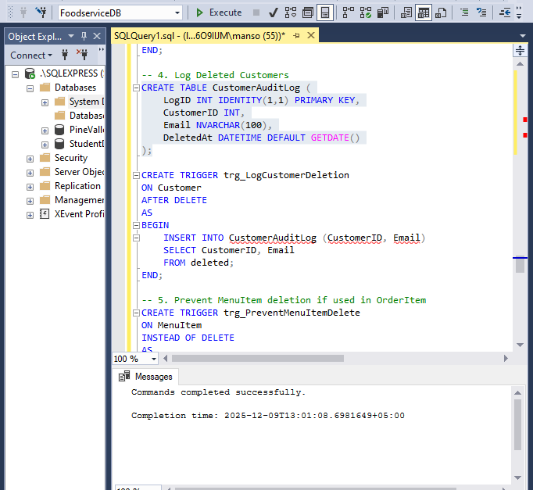

Trigger:
CREATE TRIGGER trg_LogCustomerDeletion
ON Customer
AFTER DELETE
AS
BEGIN
INSERT INTO CustomerAuditLog (CustomerID, Email)
SELECT CustomerID, Email
FROM deleted;
END;
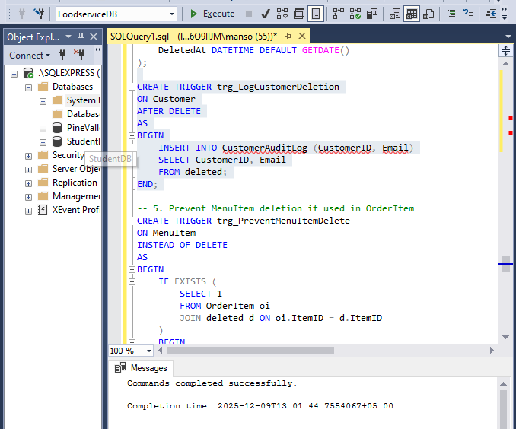

5.Prevent MenuItem deletion if used in OrderItem
- Uses INSTEAD OF DELETE to check if a MenuItem is currently referenced in any existing OrderItem record before proceeding with deletion.
- Upholds historical data integrity by preventing the removal of items that have been part of completed transactions, ensuring past order details remain accurate.

CREATE TRIGGER trg_PreventMenuItemDelete
ON MenuItem
INSTEAD OF DELETE
AS
BEGIN
IF EXISTS (
SELECT 1
FROM OrderItem oi
JOIN deleted d ON oi.ItemID = d.ItemID
)
BEGIN
RAISERROR ('Cannot delete Menu Item because it is used in an Order.', 16, 1);
RETURN;
END
DELETE FROM MenuItem
WHERE ItemID IN (SELECT ItemID FROM deleted);
END;
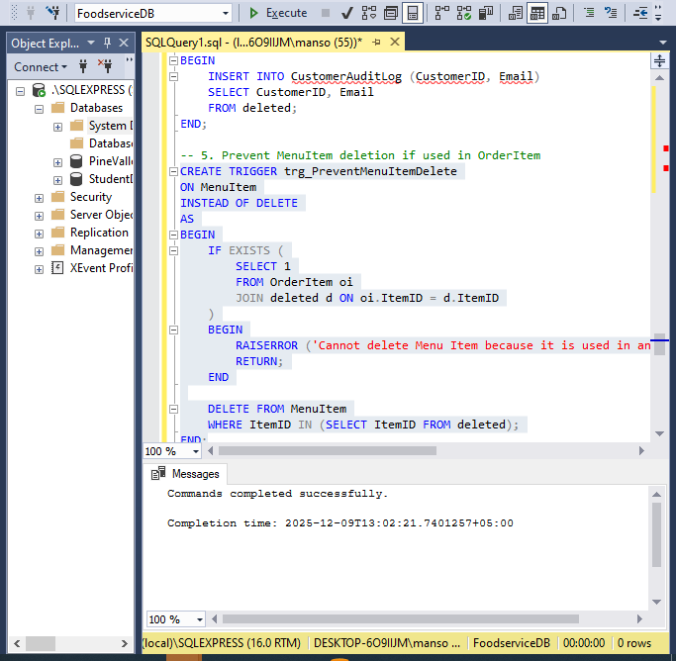

Transactions
1.Update Order Status & Change Rider Availability Together
- Executes two sequential status updates—marking the order as 'Delivered' and the rider as 'Available'—within one transaction.
- Enforces Consistency by guaranteeing that the Rider's status is only updated after the Order is confirmed delivered, preventing logical business errors.

BEGIN TRY
BEGIN TRANSACTION;

-- Mark Order as Delivered
UPDATE [Order]
SET Status = 'Delivered'
WHERE OrderID = 6001; -- replace with actual OrderID

-- Make Rider available
UPDATE Rider
SET Availability = 1
WHERE RiderID = 5001; -- replace with assigned RiderID

COMMIT TRANSACTION;
PRINT 'Order delivered successfully.';
END TRY
BEGIN CATCH
ROLLBACK TRANSACTION;
PRINT 'Transaction failed: ' + ERROR_MESSAGE();
END CATCH;
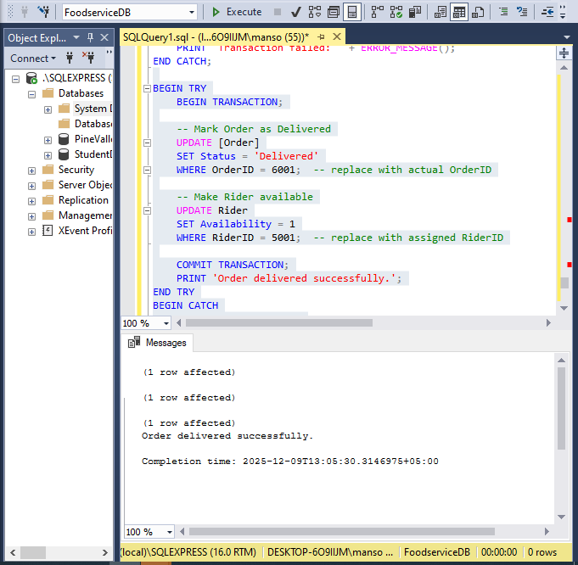
2.Cancel Order + Delete Payment + Delete Items
- A controlled cleanup process that deletes dependent records (Payment and OrderItem) before deleting the main Order record.
- Ensures Referential Integrity during cancellation by safely preventing the creation of orphaned payment or order item records.

BEGIN TRY
BEGIN TRANSACTION;

-- Delete related Payment
DELETE FROM Payment
WHERE OrderID = 6001; -- replace with the OrderID to cancel

-- Delete related Order Items
DELETE FROM OrderItem
WHERE OrderID = 6001;

-- Delete the Order itself
DELETE FROM [Order]
WHERE OrderID = 6001;

COMMIT TRANSACTION;
PRINT 'Order canceled successfully.';
END TRY
BEGIN CATCH
ROLLBACK TRANSACTION;
PRINT 'Transaction failed: ' + ERROR_MESSAGE();
END CATCH;
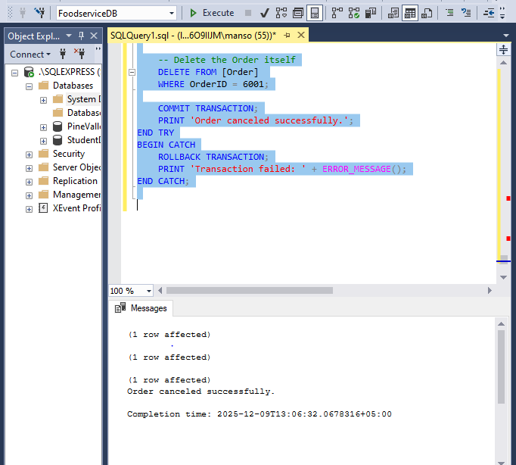

ROLES
Admin_Role
- The Admin_Role is granted full administrative access (SELECT, INSERT, UPDATE, DELETE) across all seven core database tables to provide complete system management and oversight.

CREATE ROLE Admin_Role;

GRANT SELECT, INSERT, UPDATE, DELETE ON Customer TO Admin_Role;
GRANT SELECT, INSERT, UPDATE, DELETE ON Restaurant TO Admin_Role;
GRANT SELECT, INSERT, UPDATE, DELETE ON MenuItem TO Admin_Role;
GRANT SELECT, INSERT, UPDATE, DELETE ON Rider TO Admin_Role;
GRANT SELECT, INSERT, UPDATE, DELETE ON [Order] TO Admin_Role;
GRANT SELECT, INSERT, UPDATE, DELETE ON OrderItem TO Admin_Role;
GRANT SELECT, INSERT, UPDATE, DELETE ON Payment TO Admin_Role;

Restaurant_Manager_Role
- Grants the necessary permissions (SELECT, INSERT, UPDATE) to manage the menu items and update the restaurant's details.
CREATE ROLE Restaurant_Manager_Role;

GRANT SELECT, INSERT, UPDATE ON MenuItem TO Restaurant_Manager_Role;
GRANT SELECT, UPDATE ON Restaurant TO Restaurant_Manager_Role;

Rider_Role
- Provides minimal access to view assigned orders and update the rider's personal availability status.
CREATE ROLE Rider_Role;

GRANT SELECT ON [Order] TO Rider_Role;
GRANT UPDATE ON Rider TO Rider_Role;

Customer_Role
- Allows the end-user to browse restaurants and menu items and track the status of their own placed orders.
CREATE ROLE Customer_Role;

GRANT SELECT ON Restaurant TO Customer_Role;
GRANT SELECT ON MenuItem TO Customer_Role;
GRANT SELECT ON [Order] TO Customer_Role;

